SPECIALIST MATHS UNITS 3 & 4
TRIAL EXAMINATION 2
SOLUTIONS
2024

Section A – Multiple-choice answers
1. D 6. A 11. B 16. C
2. B 7. B 12. D 17. D
3. C 8. A 13. A 18. D
4. C 9. C 14. C 19. A
5. C 10. A 15. D 20. C

Section A - Multiple-choice solutions

Question 1

When negating a statement involving a quantifier, we interchange a ‘there exists… such that’ with a ‘for all’ and negate the rest of the statement.

the solution is
The answer is D.

Question 2
Consider the options:

Direct Proof
Let
- tough to prove this is even

Mathematical Induction
Not a sum/sequence of terms that lends itself to induction.

Converse
The converse of a statement is not necessarily always true (even though it is in this case).

Contrapositive
When a proof is hard to do using a direct proof, the contrapositive can be easier to prove. The contrapositive is

For any , prove that if is odd, then is odd

Which can be quite easily done.

The answer is B.
Question 3
Euler’s method requires at each step for the y-value to be the previous y-value + the step size multiplied by the differential equation at the previous point (as per formula sheet shown) and for the x-value to increase by the step size h. This narrows down our choices to C or D.

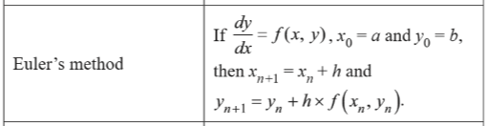

For the pseudocode to work, we need to calculate the next y-value using the previous x and y-values, so we cannot alter the x value first.

Therefore the answer is C.

Question 4
Given , the domain of is ,

The range of is . The graph is then dilated by a factor of from the x-axis, to give a range of .
The graph is then translated units in the negative direction of the y-axis to give a range of .

The answer is C.

Question 5

Given the points , and , we can obtain the vectors
and

Using the cross product function on the CAS, .

By definition, the magnitude of the cross product, , where is the angle between and . From the diagram below, this tells us that is the area of the parallelogram spanned by the two vectors, as shown in the diagram below.
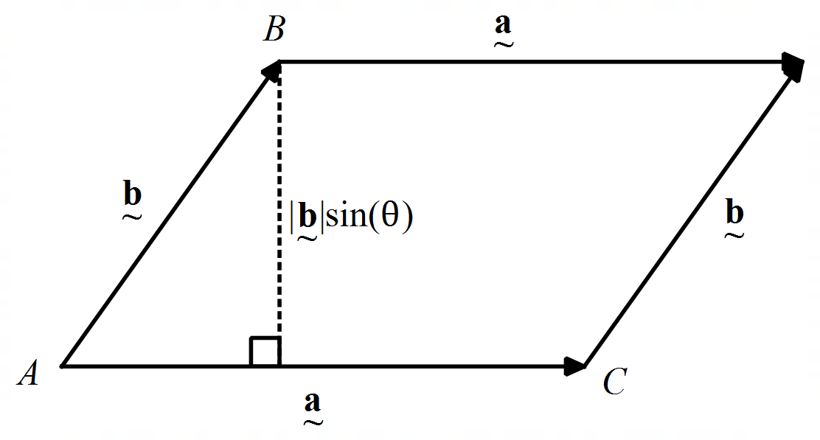

Therefore to find the area of the triangle, we can
take half of this value.

Area

The answer is C.

Question 6

If two lines are not parallel and do not intersect then they are skew lines.

Given the following vector equations of lines:

For the lines to be parallel, , but by inspection it is clear that there is no possible value of m.

If the lines are not parallel, we can determine the value of such that the two lines intersect by equating components of the vectors

….. (1)
…..(2)
…..(3)

Solving (1) and (2) simultaneously on the CAS gives us and .

Substituting these values into (3) to find :

Solve for a:

The lines are therefore skew lines provided they do not intersect, i.e. when .
The answer is A.

Question 7

For the vectors , and to be linearly dependent, find the values of and such that .

Method 1 – Solve equations simultaneously

If , then by equating components, we get the following three equations:

….(1)
….(2)
….(3)

Solving (1) and (3) simultaneously on the CAS for and :

,

Substitute these values into (2):

The answer is B.

Method 2 – Using the determinant of the matrix

The vectors given can be placed into a matrix as shown below. Solving the determinant of the matrix equal to 0 will find (this can be done easily on the CAS).

The answer is B.

Question 8

Let .
The answer is not B, as that vector is parallel to .

The dot product of with either vector or gives zero, so both of these vectors are perpendicular to , hence options A and C are perpendicular to .
We need to select the vector from these two with a length of two units.
, therefore a unit vector parallel to would be and a unit vector parallel to would be .

Therefore, a vector parallel to with a length of two units would be .
Checking the vector parallel to with a length of two units – this would be , which is not what option C states.
The answer is A.

Question 9

If , then

The answer is C.

Question 10
If , then in polar form, .
This is real and positive.
The answer is A.

Question 11

is a circle with a centre of and a radius of 2.

Draw a quick sketch of the circle as shown.

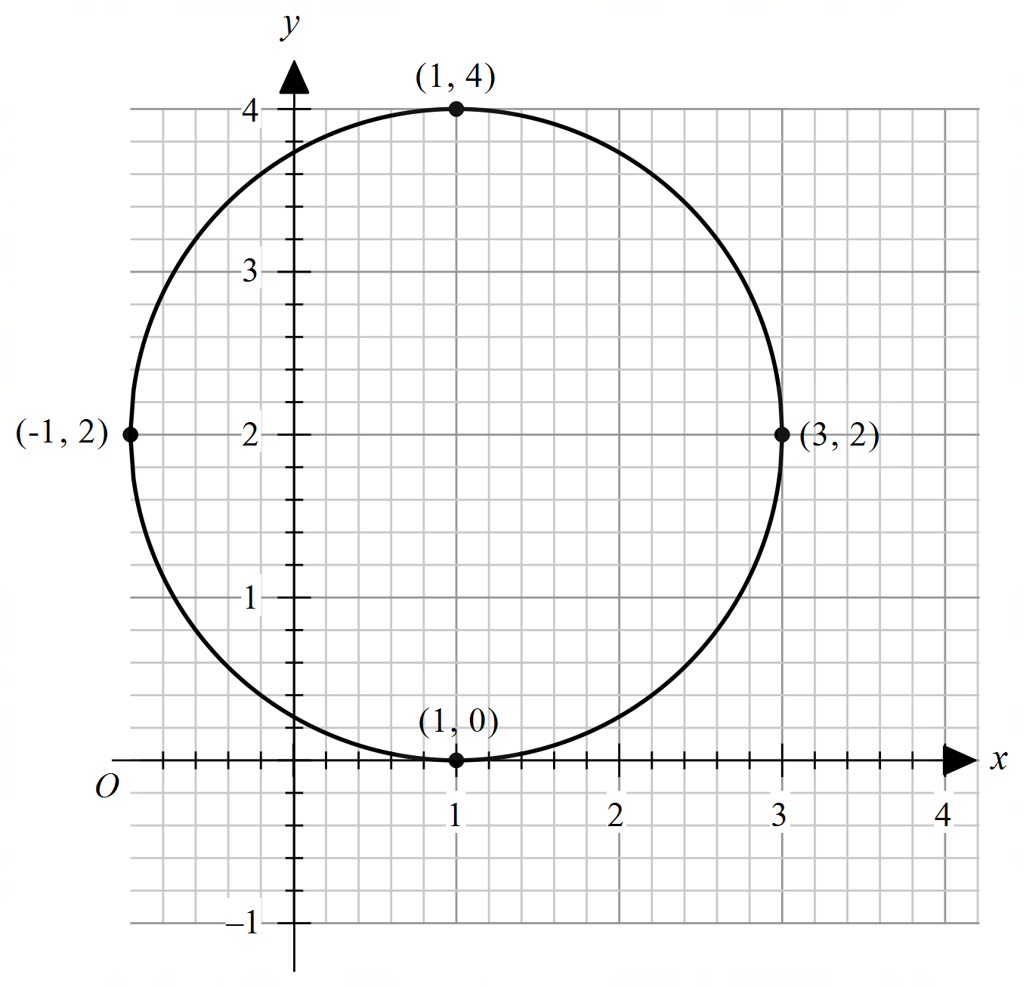

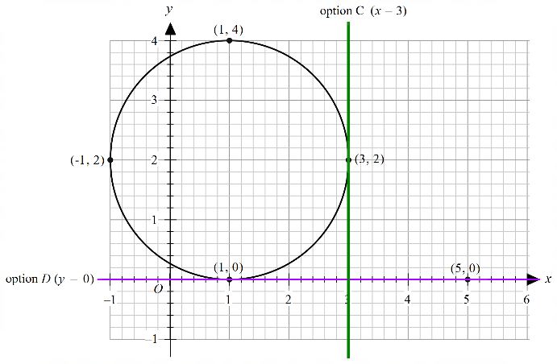
Option C is the vertical line which
would be a tangent to the circle at
, so would not intersect twice
as shown

Similarly, Option D is the horizontal
line which would touch the circle
once at as shown.

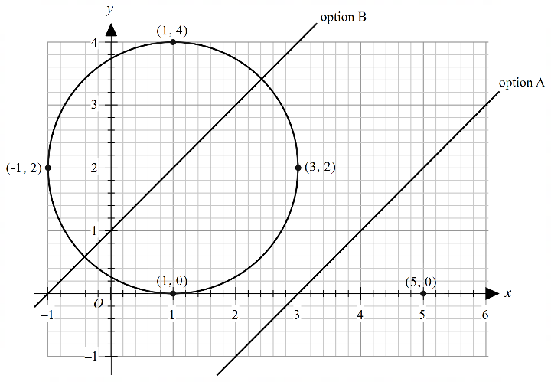
Options A and B are both perpendicular
bisector lines.

Option A is the perpendicular bisector of the points and and is shown.

Option B is the perpendicular bisector of the points and so would cut through the circle as shown.

The answer is B.

Question 12

Given , then

and

and

Using ,

Using ,

The answer is D.

Question 13

Given ,

Given ,

The velocity vector gives the direction of motion of the particle at any time t.

.
The answer is A.

Note: the initial position was given as a distractor.

Question 14

Solve for on the CAS to find the values of a and b:

and
A quick sketch on the CAS shows that over the domain .
Area
(CAS)
The answer is C.

Question 15

Given , ,

The answer is D.

Question 16

Given ,

When speed = 4, solve for t (as speed is the magnitude of v).

, (t > 0)
, (t > 0)

and

The answer is C.

Question 17
let
when
when

The answer is D.

Question 18
Looking at the slope field provided, along the line , .
This rules out options A and B, as either of those would not be 0 if .
Consider the point . It can be seen that .
For option C, substituting in gives , whereas for option D, .
The answer is D.

Alternatively, each option’s slope field can be sketched on the CAS and those that do not look like the given slope field can be rejected.

Question 19

Let X_{n} be the normal random variable representing the distribution of the lifetime of machine n. Since the lifetime of each machine is independent of the others:

and

So 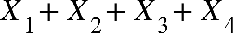 follows a normal distribution denoted by

using the CAS
= 0.0668

The answer is A.

Question 20

The width of the confidence interval is given by , where s is the standard deviation, n is the sample size and z is used to determine the level of confidence.

To decrease the width of the confidence interval by 80%, we need to multiply by
The original sample size was n.

Let the new sample size (for the confidence interval with reduced width) be xn.

So

solving for x:

So the original sample size must be multiplied by a factor of 25.

The answer is C.

SECTION B

Question 1 (9 marks)

a. Given .

Do a quick sketch on the CAS if needed.

Maximal domain D is and range of is R. (1 mark)

b. When rotating about the y-axis, the volume .
Let .
(1 mark – solve for x by hand or on the CAS)

(1 mark – correct formula including terminals)
cm³ (correct to three decimal places) (1 mark)

c.
cm³
cm³ (1 mark – equivalent forms OK)

d. Using ,
and (given)

Using the chain rule,
(1 mark – use chain rule with their )
When , cm/min (correct to four decimal places)
(1 mark)

e. Given ,

i. Using the CAS, .

Given and , provided .

If , , unless also equal to 0, in which case is undefined. Therefore, the value of b has no direct impact on the sign of , so .

If , then the function is undefined, hence also undefined.

Hence for we require , and .

(1 mark)

ii. Solve .
solve for x:

Therefore x-intercept is negative if and , or
if and .

(1 mark)

Question 2 (12 marks)

a. and .
(as complex number is in quadrant 1). (1 mark)

Alternatively, write in polar form on the CAS and read Argument.

b. i.
(alternatively, use CAS solution)
as required (1 mark)

ii. Method 1 – using De Moivre’s Theorem
Given one solution to is , and because the equation is of the form , De Moivre’s Theorem tells us that all four solutions will be the same distance from the origin, and the spacing between the Arguments of all four solutions will be apart.
(1 mark)

other solutions are , and . (1 mark)

Method 2 – Solve the equation on the CAS

Solve on the CAS for z: (1 mark)

Solutions are , and . (1 mark)

c.
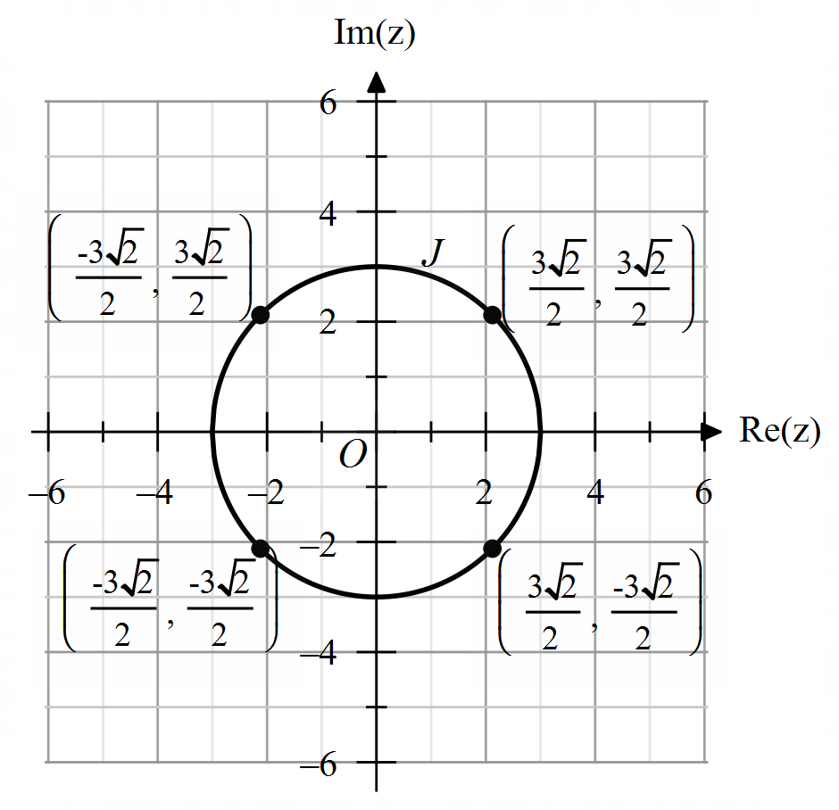

(1 mark – circle in correct location – radius of 3)
(1 mark – 4 points with coordinates)

d. is a circle with a radius of 3 and a centre of (3, 3) as shown below.

(1 mark)
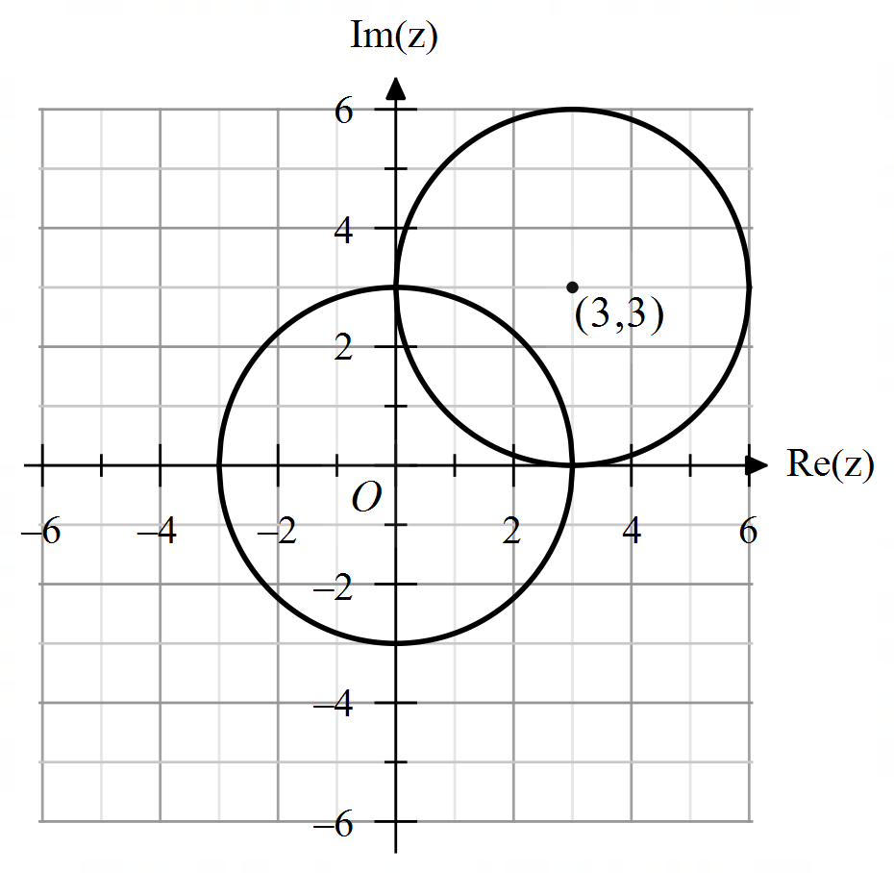

e. Required area (shaded in the diagram below) between two circles is two segments of equal area, as both circles have the same radius.

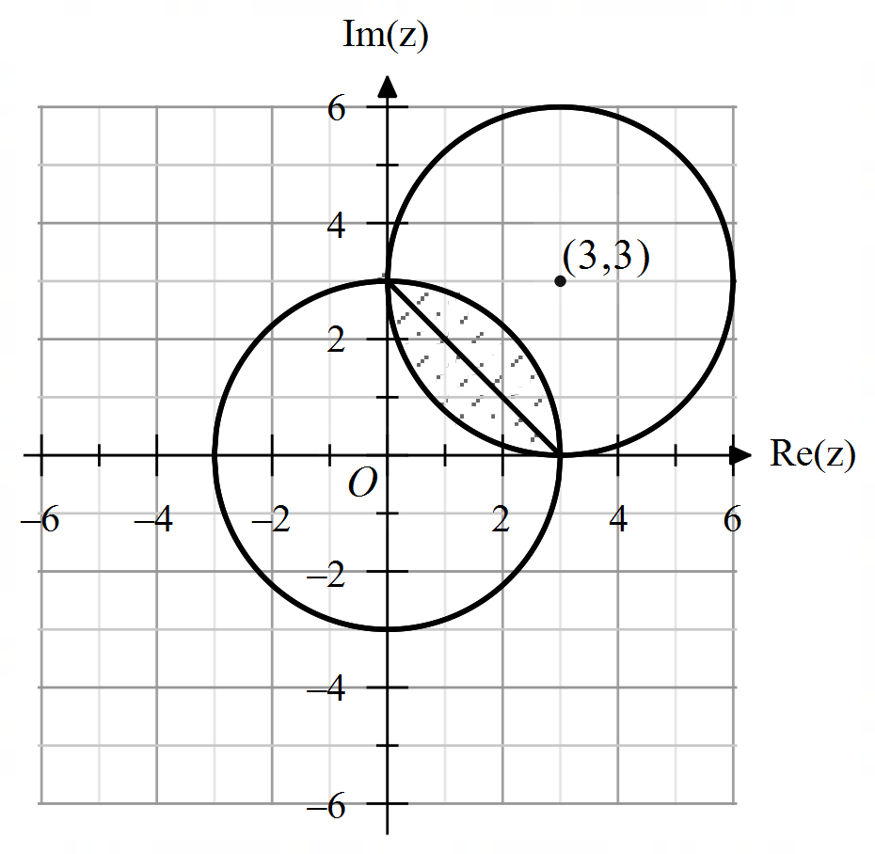

Area of a segment rule is given on the formula sheet.
Area of one segment
(1 mark)
units²

area between two circles units² (1 mark)

f. Given that and , this defines all the points in the region bound between the two circles shaded in the diagram.

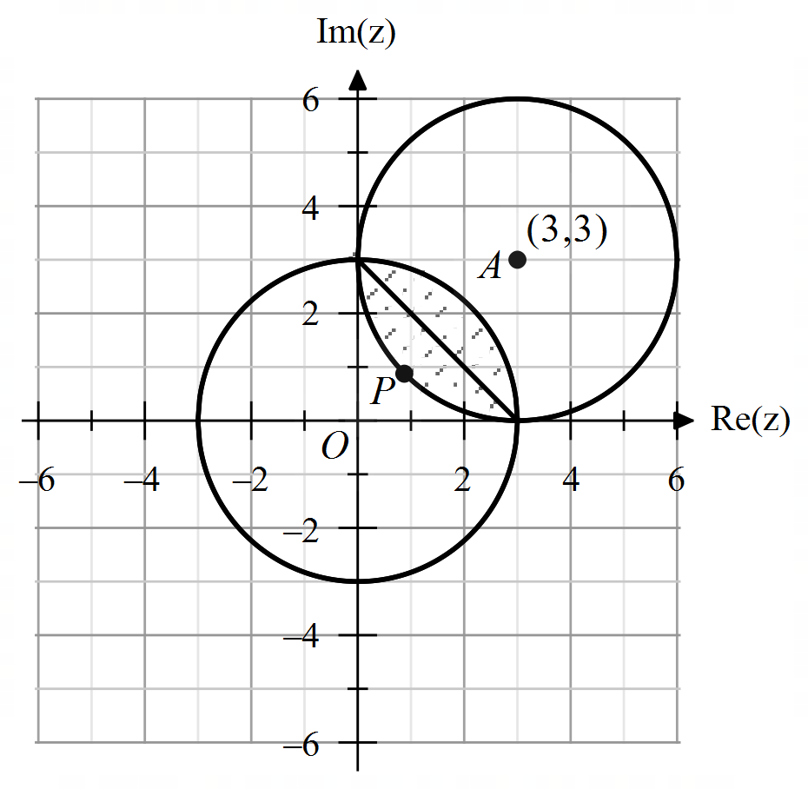

If the centre of the circle is O and the centre of the circle is A, then .
(1 mark)

Let P be the point along OA on the circle such that O, P and A are collinear.
Given (radius of the circle), .
(1 mark – determine length OP)

Since point P is the closest point on the circle to the origin, it is the point where is a minimum. Every other point in the shaded region shown is further away from the origin, so the minimum value of is .

(1 mark – decent explanation to arrive at solution)

Question 3 (10 marks)

a. Given , to check whether points A, B and C lie on the plane, substitute their values in for x, y, z.

:
:
:
(1 mark)

b.

Let .
Let .
Let .
(1 mark – two vectors in plane)

(1 mark)

Note: other equations are possible if the points B or C are used and/or the vector is used as one of the vectors.

c. Distance from point to the plane is given by , where Q is any point in the plane and is a unit vector normal to the plane.

Using ,
(1 mark – find vector )
Also .

(1 mark – correct rule use and )
= units (1 mark)

d. Given is parallel to , equation of is of the form ,
.
(1 mark)

Substitute in point :

the plane has the Cartesian equation .
(1 mark)

e. Given and .

Therefore, an equation of line L is , .
Note: other equations for L are possible if the point P and/or the vector is used.

(1 mark)

Substitute components of L into equation for :

Solve for t:

point of intersection is .
(1 mark)

Question 4 (10 marks)

a. Given ,
, .
(1 mark)
(1 mark)
where

as required.
(1 mark – must show)

b.

Substitute t = 0, ,

(1 mark – must show)

c.

Substitute , ,

(1 mark)

(1 mark)
(1 mark)

d.
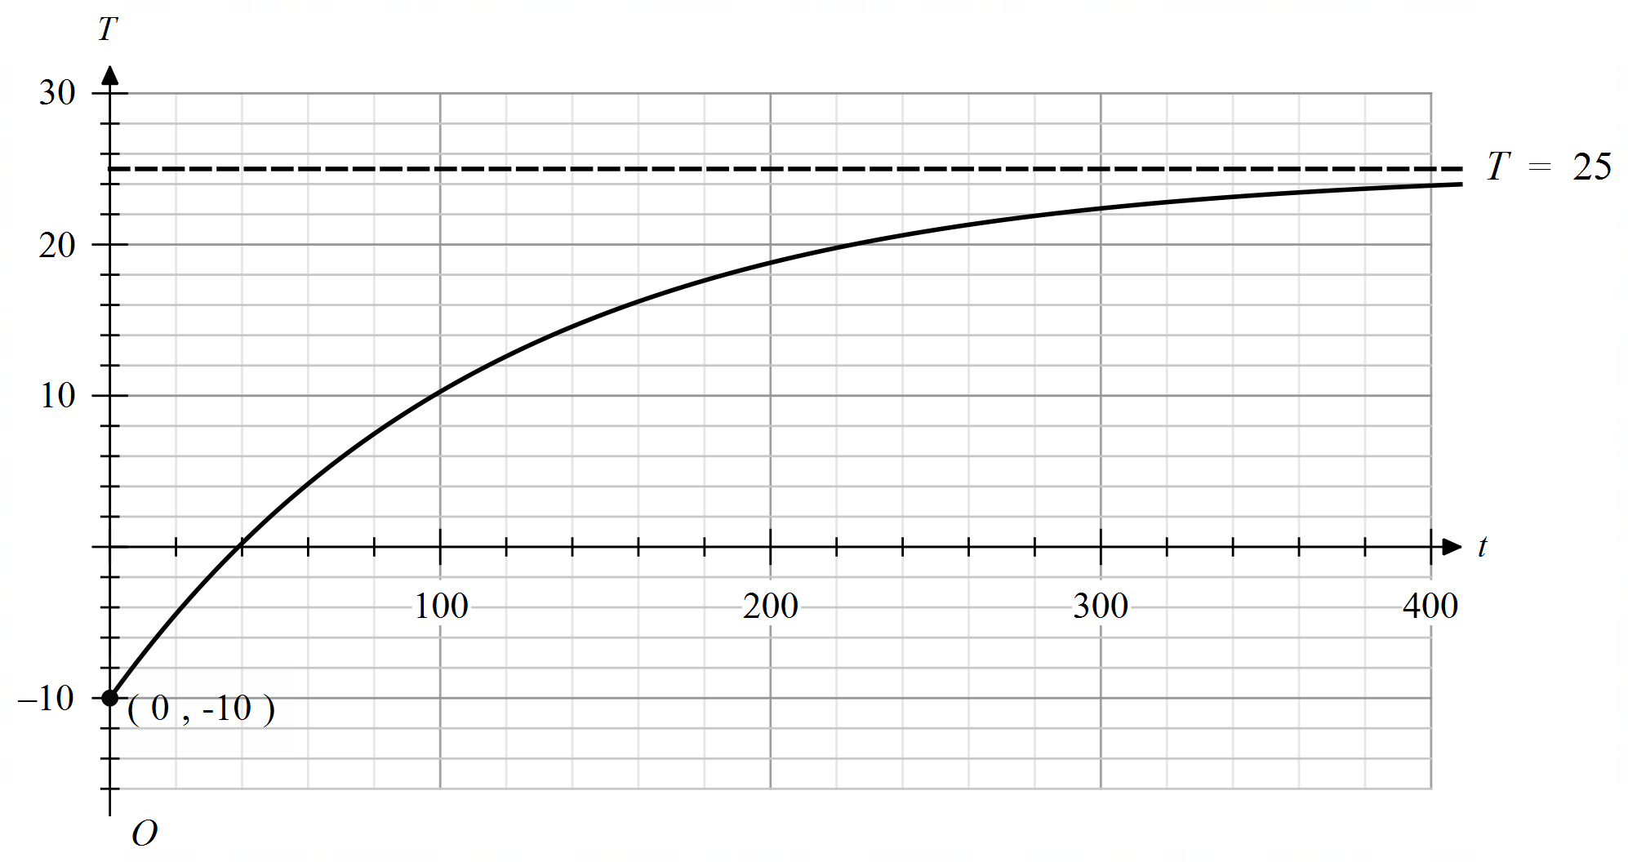

(1 mark – correct shape with t-intercept in approximate correct spot)
(1 mark – asymptote with equation and T-intercept with coordinates)

e. Solve for t:

minutes (correct to one decimal place) (1 mark)

Question 5 (9 marks)

a. i. Given , initial position is .

.

initial coordinates are and initial height is one metre
( component).
(1 mark – both answers)
ii. speed

(1 mark)

m/s (1 mark)

b. Using arc length formula given in the question, ,

, ,

metres (1 mark)

c. For the tip of the arrow to hit the red dot on balloon 2, both objects need to be at the same point at the same time (paths collide). We need to consider that the arrow is fired three seconds after balloon 2.

Hence, if we consider t to be the time after the arrow is fired, we need to find t such that .
(1 mark – recognise to adjust rule for different start times)

-components:
solve for t:
or , but

-components:
solve for t:

-components:
solve for c given :
(1 mark)

d. Surface area of balloon 3 is .

Also given (note negative given balloon is deflating therefore surface area is decreasing).

Using chain rule, ,
(1 mark)

When , cm/hour

Therefore the radius is decreasing at a rate of cm/hour when r = 12.

(1 mark – must state decreasing at positive value)

e.

When ,

The balloon will be totally deflated when ,
hours
It takes 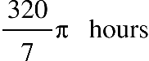.
(1 mark)

Question 6 (10 marks)

a. i. Let X represent the distribution of the number of visitors to the zoo.

(correct to four decimal places)
(normalcdf on CAS) (1 mark)

ii. Let represent the distribution of the mean of random samples of
5 days.

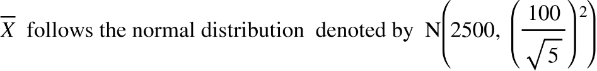
(correct to four decimal places) (1 mark)

b.
(1 mark)

c.
(1 mark)

Since p < 0.05, there is enough evidence to suggest online ticketing has changed the average attendance and that management should reject the null hypothesis.
(1 mark)

d. Given we are looking at whether the mean has changed, we are looking at a two-tail test. Hence we need to determine the value of the standard deviation of , such that the .

To do this, we use the inverse normal function on the CAS with a mean of 0 and standard deviation of 1 to determine the corresponding z-value, which is 1.9599.

(1 mark)

Solving for n gives .

Note that if n = 15, the p-value will be 0.0528, which is greater than 0.05, and when
n = 16, the p-value is 0.0455. Hence, we need a minimum sample size of 16 for management to reject .
(1 mark)

e. A type I error is when we reject the null hypothesis when in fact it is true.

(1 mark)

f. A type II error occurs when we do not reject the null hypothesis, when it is false.

Given we are testing at the 5% level of significance, we can determine the lower and upper bound values for the sample mean in order to reject the null hypothesis (each end must have an area of 0.025).

(1 mark – some recognition of two tails and values needed)

Hence, a Type II error occurs if we obtain a mean value such that .

(correct to five decimal places) (1 mark)

Note: If you were to calculate , you would get a value of 0.39121. However, this calculation does not take into account the two-tails.

